Software Requirements Specification

For

<Let’s Serve Humanity>

Version 1.0 approved

Prepared by:

M. Abdullah Waseem (Sp17-bsse-0060)

Shaikh Haris Khalid (Sp17-bsse-0046)

<Muhammad Ali Jinnah University>

**Table of** **Contents**

1. Introduction 4

1.1 Purpose 4

1.2 Document Conventions 4

1.3 Intended Audience and Reading Suggestions 4

1.4 Project Scope 5

1.5 References 5

2. Overall Description 6

2.1 Product Perspective 6

2.2 Product Features 6

2.2.1 For Donors: 6

2.2.2 Needy People: 6

2.2.3 Management Team of LSH (Admin): 6

2.3 User Classes and Characteristics 7

2.4 Operating Environment 7

2.5 Design and Implementation Constraints 7

2.6 User Documentation 7

2.7 Assumptions and Dependencies 8

3. System Features 8

3.1 System Features: 8

3.2 Functional Requirements: 9

3.3 Future Work: 9

4. External Interface Requirements 10

4.1 User Interfaces 10

4.2 Hardware Interfaces 10

4.3 Software Interfaces 10

4.4 Communications Interfaces 10

5. Other Nonfunctional Requirements 10

5.1 Usability Requirements 10

5.2 Security Requirements 11

5.3 External Requirements 11

5.4 Performance Requirements 11

5.5 Organizational Requirements 11

5.6 Operational Requirements 11

5.7 Development Requirements 11

5.8 Ethical Requirements 12

5.9 Regulatory Requirements 12

5.10 Software Quality Attributes 12

5.10.1 Performance Requirements 12

5.10.2 Safety Requirements 12

5.10.3 Security Requirements 12

5.10.4 Testability 12

6. Other Requirements 12

6.1 Availability: 12

6.2 Insatiability: 13

6.3 Integrity: 13

Appendix A: Glossary 14

Project Planning 14

Appendix B: Analysis Models 15

Use Case Diagram 15

Use case: See the Details 16

Use case: Donate 17

UML Class Diagram 18

State Diagram 18

NoSQL – ER Diagram 19

Activity Diagram 20

Test Cases 20

Appendix C: Issues List 27

Mockups 27

# Introduction

## Purpose

The purpose of this software requirement specifications is to provide a detailed description of

functionality and non-functionalities of “LETS SERVE HUMANITY”. This document will cover the system features.This project has been taken by experiencing the difficulties faced by the people while searching the needy peoples. A lot of people who are willing to help the needy people are unable to distinguish them which is the main problem. Also, some needy people need help, but they don’t know what to do and who to contact. If we talk only about Karachi there are a lot of people who need help, be it financial or any other form, but they are being a common man, so their voice is not raised to the concerned authorities.

## Document Conventions

No standardized conventions our used in this document.

## Intended Audience and Reading Suggestions

This project targets all the audience that includes both males and females that finds it difficult to arrange money for weddings, for school fees, with the age of above 15. And they should have a facility of internet available.

* Donors (who will donate the money through this application)
* Needy People (Those people who need help)
* The management team of LSH/Admin (who can give and update the details of the cases daily)

## Project Scope

Some applications are running around but again if an application already exists doesn’t mean that it is perfect, nothing is perfect. There are some flaws that we identified in those applications that are:

* Some applications only had a list of categories with no detail of cases.
* While some applications had the cases but no progress of how things are going and what is the result in the end.

We have three categories for people to donate these are Donation, Sadaqah, and Zakat. We of course will utilize the donation based on their categories while keeping in mind our religious beliefs.

There are certain elements that we will look upon our priority will be solely based upon the seasons. Most of the cases related to fees of the students come around 2 times of the year, Spring and Fall. So, at this time our focus will be on gathering students’ fees and helping them in their studies. The majority of the weddings take place 2 times in a year, June-July and Nov-Dec season. In these 2 seasons, our priority will be to look after the wedding expenses of people who can’t afford it. If we mentioned the priority it doesn’t mean that at this time we will not look after any other cases in this duration. We will take care of all cases but first, our focus is on completing the high priority cases.

## References

This document is written by group members only as the idea of the project is original so there was no need to add a reference to other authors or publishers.

# Overall Description

## Product Perspective

This mobile application can be used by all the registered users, such that it is creating a medium between the needy people and the ones who are willing to donate and the management staff of the LSH team. Registered Users can upload a case according to its needs by filling in the required details and others can donate by select the payment methods and case. Data will be stored in a database from where the management team of Let’s Serve Humanity will use the database to add, modify, and delete data.

## Product Features

### For Donors:

* Donors need to create their accounts if they want to use the application for donations.
* Donors can find the cases on the front page based on the priority.
* Donors can review the amount given for any case.
* Donors can donate in more than one category and cases also.
* Donors can also select the category in which they have to donate their money.
* Donors can contact the management team and give feedback to the application.
* Donors can see the target amount, collected amount, and the time duration of the case.

### Needy People:

* Needy people need to create their accounts if they want to upload a case.
* Needy people can post a case according to their needs.
* Needy people will fill a form that includes the details about the case.
* Needy people can contact the management team of LSH using the application.
* The Management Team can give guidance if needy people find any difficulty.

### Management Team of LSH (Admin):

* The management team will receive the form filled by needy people.
* The management team can track the status of a case and keep updating it.
* The management team can verify the case and decide to approve or reject the case.
* The management team can arrange the cases based on their priority on the home screen.
* The management team can verify the cases of needy people before approving or rejecting any case and only the approved cases appear on the home screen.
* The management team can record donors and donate to each case.

## User Classes and Characteristics

Two types of users will be using this system. One is donors and the other one is needy people. Both donors and needy people will use this mobile application. Donors can use this application to see the details of any case and to donate money for it also will be able to donate casually. The Needy People can use this application to give the details of its needs so that donors can see it and help those who are in need.

## Operating Environment

This system is operating on the web portal. This system will interact with the server and the database. The server operates on a windows 10 operating system with 40 GB ram and 100 TB storage. The data is stored using Mongo DB (database).

## Design and Implementation Constraints

* There can be various constraints for both mobile applicants and web users.
* Mobile applicants can face application malfunctions depending on their mobile type since this app requires internet or Wi-Fi connection, many people might not have this facility, the internet is not always or everywhere available, this might limit its effectiveness.
* Web-users might also face the problem. Internet downfall can cause my progress to slack.
* Not all systems are well built, some are of new technology while some are still old, the old systems have a slow response time.

## User Documentation

The mobile application will facilitate the client’s side by side when they will be performing actions. They will be trained by tutorials that will help them operate the system.

## Assumptions and Dependencies

The application will provide 24hr details to the donors and the management of LSH if the internet is available. The product will always be used on mobile phones that have enough hardware resources available. A mobile application can face application malfunctions depending on their mobile type since the app requires the internet and it may not be available every time. Internet downfall can cause my progress to slack. Not all systems are well built; some are of new technology while the same our still old, the old systems have a slow response time. Application is dependent on ISP’s to work properly, for proper communication between components of the system and between systems itself. Another assumption for users is that the product will always be used on mobile phones that have enough performance. If the phone does not have enough hardware resources available for the application, for example, the users might have allocated them with other applications, there may be scenarios where the application does not work as intended or even at all.

# System Features

## System Features:

The front of the mobile application contains approved cases.

* The front page of the mobile application which is home page contains all the current cases which are arranged priority wise, which is of course the time factor, the priority will keep on changing according to the cases and seasons.
* The home page consists of all the approved cases.
* Clicking on any case will give the detail of the case.
* Payment options (easy paisa, jazz cash, bank transfer)
* On the home page, there is an option of casual donation for the donor.
* There shall be a login system for users.
* Backend for admin: It’s required for verification or update cases etc.

## Functional Requirements:

* The donor shall be able to check the status of the cases online.
* The donor shall be able to select the categories for donation.
* The donor shall be able to review its charity given for a case.
* Needy People shall be able to post their cases through the application.
* The management team of LSH shall be able to update the cases frequently.
* The system shall be able to allow the donor/needy people to contact the management in case of difficulty.
* The management team of LSH shall be able to have a close check of cases under their supervision.
* The system shall be able to notify the management team if any malfunction occurs or any mishaps happens.
* The management team shall be able to have a close look at the system to avoid any interruptions from unauthorized users.
* The system shall be able to notify the management team when the amount required for a case is achieved.
* The system shall be able to provide ease to both, donors and needy people to get the work done efficiently and effectively.
* The system shall be able to prevent any disruption from an external entity.
* The needy people shall be able to fill requirements form to post a case.
* The system shall be able to notify the donor if he has donated for any case.

## Future Work:

Users can donate old/new clothes through this application. They can also donate books that are no longer useful for them, Blood donation can also be done through this application. Web Portal will also be built for this application.

# External Interface Requirements

## User Interfaces

At first, the login page will be visible to both the donor and needy people. As soon as they log in the application the cases page will appear on the screen. The status of running cases will be shown on the screen. Users can donate, add new cases, can view the projects of LSH team, can get to know the history of LSH.

## Hardware Interfaces

Mobile phones used to run specific applications and computers interact with application servers.

## Software Interfaces

The mobile application communicates with the application servers to get information from the database to get the information about the usage. The communication between the database and the mobile application consists of operation concerning both reading and modifying the data.

## Communications Interfaces

The communication between the different parts of the system is important since they depend on each other. However, in what way the communication is achieved is not important for the system and is therefore handled by the underlying operating systems for the mobile application.

# Other Nonfunctional Requirements

## Usability Requirements

Both the management team and the donors can use this system to monitor but a donor cannot make changes in the system.

## Security Requirements

The login and password of the user are required to login to the application. The data of donor/needy people is visible only to the donor/needy people and not to anyone else, in case of data being delivered to an unauthorized user, the donor/needy people will be notified.

## External Requirements

Those who have signed into the system will receive details, any outsider will not be permitted to access the system.

## Performance Requirements

System updates every 5 minutes, so any changes or status can be updated efficiently.

## Organizational Requirements

The system should follow all the organizational norms, any functionality other than organizational norm should not be included in the system. The system should authorize specific users with limited access as it will be against organization culture to give access to personal records of donors and needy people.

## Operational Requirements

The system is capable of handling 100 requests at a time means at one time the system is capable to perform either data entries or retrievals. Requests more than one thousand will be placed in the queue so that as soon as one user closes its operation other can continue with his own.

## Development Requirements

System and subsystems should be developed using specific development tools and methods. Development methods other than specified ones cannot be used.

## Ethical Requirements

The system is well protected, it allows the needy people and donors to login and password to either see data or to access data. There are certain changes that you cannot make without certain authorizations.

## Regulatory Requirements

The system obeys laws of regulatory bodies and every functionality provided in systems does not exceed the limits and boundaries that are not specified by regulatory bodies.

## Software Quality Attributes

### Performance Requirements

If at most 100,000 people logins in the application if will not affect its performance.

### Safety Requirements

The users can enter their correct information without any fear as their no such change of any system hack or anything like that in this application.

### Security Requirements

Only the users that are registered through this app can only log in to the system nonregistered users have to register first to see what is inside the system. The system is protected from viruses.

### Testability

The system is easy to test it can also be divided into different modules so that it is easier for testing.

# Other Requirements

## Availability:

The system shall be available 97% in a year and will be shut down for at least 4 hours on Sunday morning from 6 am to 9 am twice a year.

## Insatiability:

The system shall be taken a minimum of 2 minutes on installation while the time is dependent on how fast the device will work. The maximum time taken would be 5 minutes for any amateur user.

## Integrity:

The Bridge of information between the donor and LSH team is based on encryption so that no other person can overwrite then.

# Appendix A: Glossary

## Project Planning

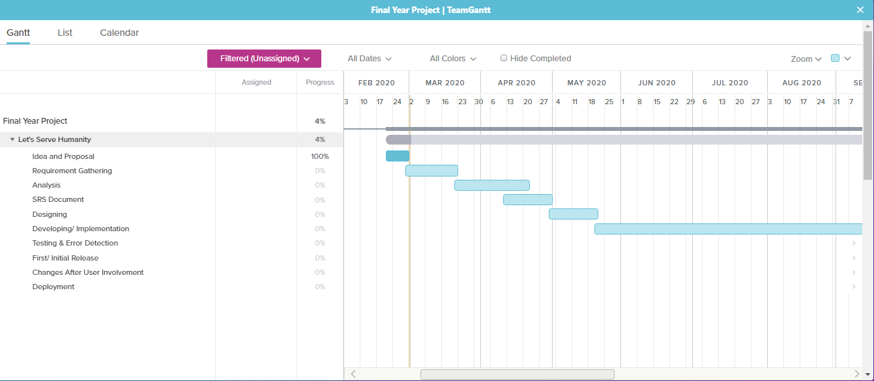

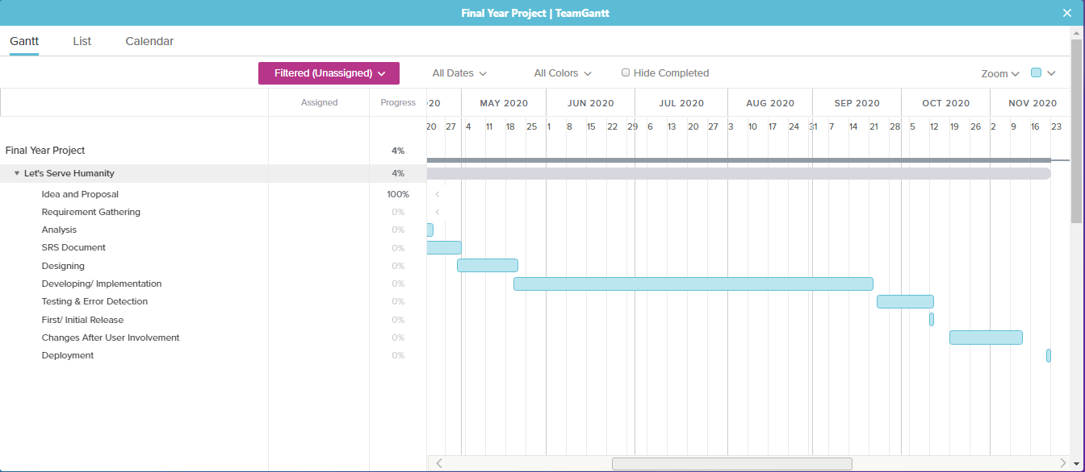

# 

# Appendix B: Analysis Models

## Use Case Diagram

### Use case: See the Details

|  |  |
| --- | --- |
| Description | The donor and management team can see details of the cases given by the needy person. |
| Preconditions | Needy Condition should enter its requirements. |
| Data | A needy person can fill the requirements on the form given by the admin. |
| Stimulus | A needy person clicks on submit after filling the requirement in the form. |
| Response | Admin will first verify the details and then display them on the application if verified. |
| Flow of event | * Open mobile application * User will log in the system * A needy person enters the requirements on the upload case page. * Admin will verify the requirements and display them on the approved case page. * Donors can see the details of the cases. |
| Postcondition | Donors can donate money by selecting a case. |
| Comment | Needy Persons must enter the correct requirement according to their needs because it will first be verified by the management team. |

### Use case: Donate

|  |  |
| --- | --- |
| Description | As the cases on the home page are shown, users can see the details of the cases and then donate for them. |
| Preconditions | Donors first need to be registered and logged in the system. |
| Data | Donors can donate casually and also should first select the case and then fill in the required details (Credit card number, CNIC number, etc.) |
| Stimulus | Donor clicks on donating after filling requirements in the payment details to proceed with the payment. |
| Response | The details will be verified first and then the donor will get a message of successful payment done. |
| Flow of event | * Open mobile application * The donor will log in the system * The donor can casually donate by clicking the above donate button or will select a case from the home page and then donate by entering their details. * The details will be verified first and then the donor will receive a message of payment done successfully if verified. * Donors can see the donation which is collected for the case. |
| Postcondition | After the payment donors will be notified if the case is complete or still payment required if the target is not complete. |
| Comment | Donors must enter correct information because it will first be verified by the easy paisa, jazz cash, or any bank. |

## UML Class Diagram

## State Diagram

## NoSQL – ER Diagram

## Activity Diagram

## Test Cases

|  |  |  |  |
| --- | --- | --- | --- |
| Project Name: Let’s Serve Humanity | | | |
| Test Id | 01 | Test Designed By: | M. Abdullah |
| Test Title: | Test login functionality | Test Designed Date: | 1st May 2020 |
| Description | Test login with invalid details (Password should contain 8 characters) | | |
| S. No | Test Steps | Test Input | Expected Results |
| 1 | Open login | Click login | successful |
| 2 | Enter username | Abd | valid |
| 3 | Enter password | Abc123 | invalid |
| 4 | Click submit |  | Login failed |
| Project Name: Let’s Serve Humanity | | | |
| Test Id | 02 | Test Designed By: | M. Abdullah |
| Test Title: | Test login functionality | Test Designed Date: | 1st May 2020 |
| Description | Test login with valid details | | |
| S. No | Test Steps | Test Input | Expected Results |
| 1 | Open login | Click login | successful |
| 2 | Enter username | Abd | valid |
| 3 | Enter password | Abd12345 | valid |
| 4 | Click submit |  | Login successful |

|  |  |  |  |
| --- | --- | --- | --- |
| Project Name: Let’s Serve Humanity | | | |
| Test Id | 03 | Test Designed By: | M. Abdullah |
| Test Title: | Test the register user functionality | Test Designed Date: | 1st May 2020 |
| Description | Verify register users with invalid details (Contact No. should be of 11 digits). | | |
| S. No | Test Steps | Test Input | Expected Results |
| 1 | Open Register User | Click register user option | Open successfully |
| 2 | Enter username | Abd | valid |
| 3 | Enter password | Abd12345 | valid |
| 4 | Enter email | abd@abd.com | valid |
| 5 | Enter contact number | 123456 | invalid |
| 6 | Click submit |  | User registration unsuccessful |
| Project Name: Let’s Serve Humanity | | | |
| Test Id | 04 | Test Designed By: | M. Abdullah |
| Test Title: | Test the register user functionality | Test Designed Date: | 2nd May 2020 |
| Description | Verify register user with invalid details (Contact No. should be of 11 digits; email should contain @). | | |
| S. No | Test Steps | Test Input | Expected Results |
| 1 | Open Register User | Click register user option | Open successfully |
| 2 | Enter username | Abd | valid |
| 3 | Enter password | Abd12345 | valid |
| 4 | Enter email | abd.com | invalid |
| 5 | Enter contact number | 03032014568 | valid |
| 6 | Click submit |  | User registration unsuccessful |

|  |  |  |  |
| --- | --- | --- | --- |
| Project Name: Let’s Serve Humanity | | | |
| Test Id | 05 | Test Designed By: | Haris |
| Test Title: | Test the register user functionality | Test Designed Date: | 2nd May 2020 |
| Description | Verify register user with invalid details (Contact No. should be of 11 digits; email should contain @, the password should be a minimum of 8 characters). | | |
| S. No | Test Steps | Test Input | Expected Results |
| 1 | Open Register User | Click register user option | Open successfully |
| 2 | Enter username | Abd | valid |
| 3 | Enter password | Abd123 | invalid |
| 4 | Enter email | abd@gmail.com | invalid |
| 5 | Enter contact number | 03032014568 | valid |
| 6 | Click submit |  | User registration unsuccessful |
| Project Name: Let’s Serve Humanity | | | |
| Test Id | 06 | Test Designed By: | M. Abdullah |
| Test Title: | Test the register user functionality | Test Designed Date: | 2nd May 2020 |
| Description | Verify register user with valid details (Contact No. should be of 11 digits; email should contain @, the password should be a minimum of 8 characters). | | |
| S. No | Test Steps | Test Input | Expected Results |
| 1 | Open Register User | Click register user option | Open successfully |
| 2 | Enter username | Abd | valid |
| 3 | Enter password | Abd12345 | valid |
| 4 | Enter email | abd@gmail.com | valid |
| 5 | Enter contact number | 03032014568 | valid |
| 6 | Click submit |  | User registration successful |

|  |  |  |  |
| --- | --- | --- | --- |
| Project Name: Let’s Serve Humanity | | | |
| Test Id | 07 | Test Designed By: | M. Abdullah |
| Test Title: | Test the upload case functionality | Test Designed Date: | 3rd May 2020 |
| Description | Verify upload case functionality with invalid details (Contact No. should be of 11 digits; cnic no should contain 13 characters). | | |
| S. No | Test Steps | Test Input | Expected Results |
| 1 | Open Upload Case | Click upload case option | Open successfully |
| 2 | Enter name | Zain | valid |
| 3 | Enter contact number | 03032014568 | valid |
| 4 | Enter CNIC no | 42312451 | invalid |
| 5 | Enter address | 123, Gulshan Iqbal Karachi. | valid |
| 6 | Enter Required Amount | 100,000 | valid |
| 7 | Enter Case Description | Urgent Requirement of fees | valid |
| 8 | Click submit |  | Upload Case unsuccessful |

|  |  |  |  |
| --- | --- | --- | --- |
| Project Name: Let’s Serve Humanity | | | |
| Test Id | 08 | Test Designed By: | Haris |
| Test Title: | Test the upload case functionality | Test Designed Date: | 3rd May 2020 |
| Description | Verify upload case functionality with invalid details (Contact No. should be of 11 digits; cnic no should contain 13 characters). | | |
| S. No | Test Steps | Test Input | Expected Results |
| 1 | Open Upload Case | Click upload case option | Open successfully |
| 2 | Enter name | Zain | valid |
| 3 | Enter contact number | 0303201 | invalid |
| 4 | Enter CNIC no | 42312451 | invalid |
| 5 | Enter address | Block L, North Nazimabad, Karachi. | valid |
| 6 | Enter Required Amount | 70,000 | valid |
| 7 | Enter Case Description | Urgent Requirement of fees | valid |
| 8 | Click submit |  | Upload Case unsuccessful |
| Project Name: Let’s Serve Humanity | | | |
| Test Id | 09 | Test Designed By: | Haris |
| Test Title: | Test the upload case functionality | Test Designed Date: | 4th May 2020 |
| Description | Verify upload case functionality with valid details (Contact No. should be of 11 digits; cnic no should contain 13 characters). | | |
| S. No | Test Steps | Test Input | Expected Results |
| 1 | Open Upload Case | Click upload case option | Open successfully |
| 2 | Enter name | Zain | valid |
| 3 | Enter contact number | 03032014568 | valid |
| 4 | Enter CNIC no | 4231245145789 | valid |
| 5 | Enter address | 123, Gulshan Iqbal Karachi. | valid |
| 6 | Enter Required Amount | 100,000 | valid |
| 7 | Enter Case Description | Urgent Requirement of fees | valid |
| 8 | Click submit |  | Upload Case successful |

|  |  |  |  |
| --- | --- | --- | --- |
| Project Name: Let’s Serve Humanity | | | |
| Test Id | 10 | Test Designed By: | Haris |
| Test Title: | Test the donate functionality | Test Designed Date: | 3rd May 2020 |
| Description | Verify donate functionality with invalid details (Account No. should be of 16 digits, CNIC no should contain 13 characters). | | |
| S. No | Test Steps | Test Input | Expected Results |
| 1 | Open Case | Click on a case | Open successfully |
| 2 | Open Donate Button | Click on donate button | Open Successfully |
| 3 | Select mode of payment | Jazz cash/ Easy paisa/ Bank transfer | valid |
| 4 | Enter account number | 03032014568 | invalid |
| 5 | Enter CNIC no | 42312451 | invalid |
| 6 | Enter Amount | 10,000 | valid |
| 7 | Enter Reason of Payment | Charity | valid |
| 8 | Click submit |  | Donation unsuccessful |

|  |  |  |  |
| --- | --- | --- | --- |
| Project Name: Let’s Serve Humanity | | | |
| Test Id | 11 | Test Designed By: | Haris |
| Test Title: | Test the donate functionality | Test Designed Date: | 3rd May 2020 |
| Description | Verify donate functionality with valid details (Account No. should be of 16 digits, CNIC no should contain 13 characters). | | |
| S. No | Test Steps | Test Input | Expected Results |
| 1 | Open Case | Click on a case | Open successfully |
| 2 | Open Donate Button | Click on donate button | Open Successfully |
| 3 | Select mode of payment | Jazz cash/ Easy paisa/ Bank transfer | valid |
| 4 | Enter account number | 0303201456815498 | valid |
| 5 | Enter CNIC no | 4231245141254 | valid |
| 6 | Enter Amount | 10,000 | valid |
| 7 | Enter Reason of Payment | Charity | valid |
| 8 | Click submit |  | Donation successful |

## **Appendix C: Issues List**

## Mockups

